CREATE DATABASE bad_retaildb;

USE bad_retaildb;

CREATE TABLE stores_file (
store_id INT PRIMARY KEY,
store_name VARCHAR(100) NOT NULL,
region VARCHAR(50) NOT NULL,
city VARCHAR(50) NOT NULL
);

CREATE TABLE products_file (
product_id INT PRIMARY KEY,
product_name VARCHAR(100) NOT NULL,
category VARCHAR(50) NOT NULL,
unit_price DECIMAL(10,2) NOT NULL
);

CREATE TABLE sales_file (
sale_id INT PRIMARY KEY AUTO_INCREMENT,
sale_date DATE NOT NULL,
store_id INT NOT NULL,
product_id INT NOT NULL,
quantity INT NOT NULL,
total_amount DECIMAL(12,2) NOT NULL
);
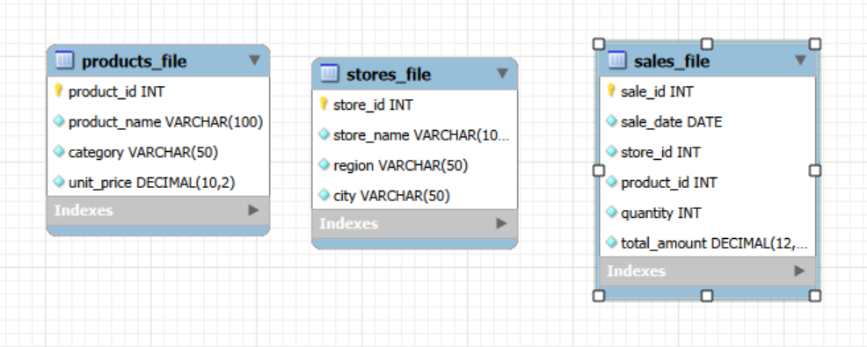

INSERT INTO stores_file (store_id, store_name, region, city) VALUES
(1, 'Yangon Central Store', 'South', 'Yangon'),
(2, 'Mandalay Plaza Store', 'Central', 'Mandalay'),
(3, 'Naypyitaw Junction Store', 'Central', 'Naypyitaw'),
(4, 'Mawlamyine Market Store', 'South', 'Mawlamyine'),
(5, 'Taunggyi Hill Store', 'East', 'Taunggyi'),
(6, 'Myitkyina Star Store', 'North', 'Myitkyina');

SELECT * FROM stores_file;
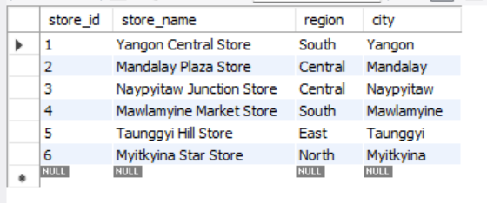

INSERT INTO products_file (product_id, product_name, category, unit_price)
VALUES
(101, 'Rice Bag', 'Grocery', 45000.00),
(102, 'Cooking Oil', 'Grocery', 12000.00),
(103, 'Instant Noodles', 'Grocery', 800.00),
(104, 'Soft Drink', 'Beverage', 1500.00),
(105, 'Shampoo', 'Personal Care', 7000.00),
(106, 'Soap', 'Personal Care', 2500.00);

SELECT * FROM products_file;
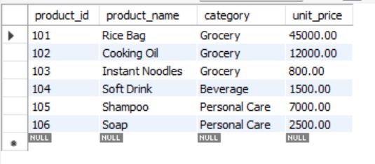

INSERT INTO sales_file (sale_date, store_id, product_id, quantity, total_amount)
VALUES
('2025-10-05', 1, 101, 10, 450000.00),
('2025-10-12', 2, 102, 20, 240000.00),
('2025-10-18', 3, 103, 100, 80000.00),
('2025-10-22', 4, 104, 60, 90000.00),
('2025-10-25', 5, 105, 15, 105000.00),
('2025-10-28', 6, 106, 30, 75000.00),
('2025-11-03', 1, 102, 25, 300000.00),
('2025-11-07', 2, 101, 8, 360000.00),
('2025-11-11', 3, 104, 70, 105000.00),
('2025-11-15', 4, 103, 120, 96000.00),
('2025-11-19', 5, 106, 40, 100000.00),
('2025-11-24', 6, 105, 12, 84000.00),
('2025-12-02', 1, 103, 150, 120000.00),
('2025-12-06', 2, 104, 80, 120000.00),
('2025-12-10', 3, 101, 9, 405000.00),
('2025-12-14', 4, 102, 18, 216000.00),
('2025-12-18', 5, 105, 20, 140000.00),
('2025-12-22', 6, 106, 35, 87500.00),
('2026-01-05', 1, 104, 90, 135000.00),
('2026-01-08', 2, 103, 140, 112000.00),
('2026-01-12', 3, 102, 22, 264000.00),
('2026-01-16', 4, 101, 7, 315000.00),
('2026-01-20', 5, 106, 55, 137500.00),
('2026-01-27', 6, 105, 10, 70000.00),
('2026-02-03', 1, 105, 18, 126000.00),
('2026-02-07', 2, 106, 50, 125000.00),
('2026-02-11', 3, 104, 75, 112500.00),
('2026-02-15', 4, 103, 160, 128000.00),
('2026-02-19', 5, 101, 11, 495000.00),
('2026-02-24', 6, 102, 16, 192000.00),
('2026-03-04', 1, 106, 60, 150000.00),
('2026-03-08', 2, 105, 14, 98000.00),
('2026-03-12', 3, 103, 180, 144000.00),
('2026-03-16', 4, 104, 95, 142500.00),
('2026-03-20', 5, 102, 21, 252000.00),
('2026-03-25', 6, 101, 13, 585000.00);

SELECT * FROM sales_file;
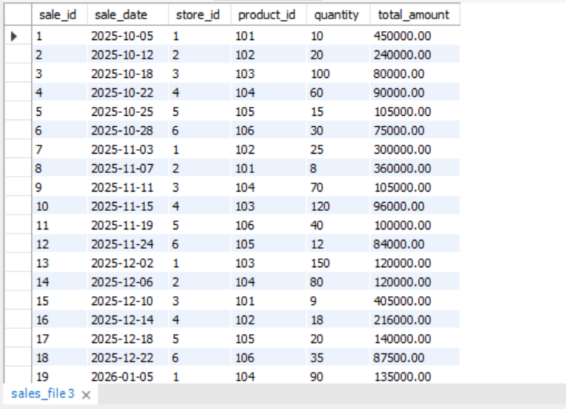

-- Without a proper integrated design, report logic becomes custom and repetitive
SELECT
s.sale_date,
s.store_id,
st.store_name,
st.region,
s.total_amount
FROM sales_file s
JOIN stores_file st ON s.store_id = st.store_id
WHERE s.sale_date BETWEEN '2025-10-01' AND '2026-03-31'
ORDER BY st.region, s.sale_date;

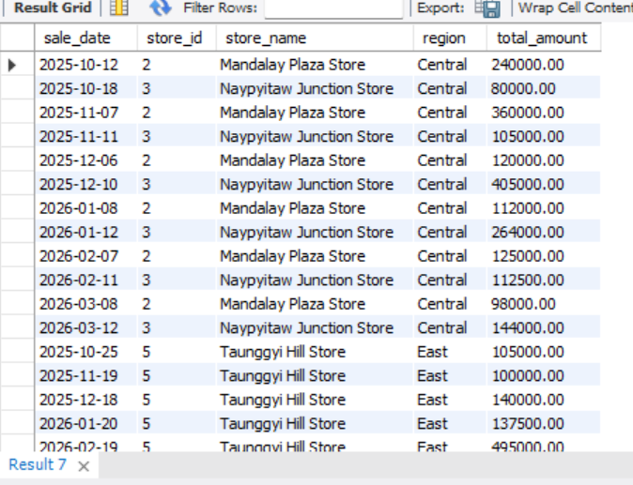

CREATE DATABASE good_retaildb;

USE good_retaildb;

CREATE TABLE stores (
store_id INT PRIMARY KEY,
store_name VARCHAR(100) NOT NULL,
region VARCHAR(50) NOT NULL,
city VARCHAR(50) NOT NULL
);

CREATE TABLE products (
product_id INT PRIMARY KEY,
product_name VARCHAR(100) NOT NULL,
category VARCHAR(50) NOT NULL,
unit_price DECIMAL(10,2) NOT NULL
);

CREATE TABLE sales (
sale_id INT PRIMARY KEY AUTO_INCREMENT,
sale_date DATE NOT NULL,
store_id INT NOT NULL,
product_id INT NOT NULL,
quantity INT NOT NULL,
total_amount DECIMAL(12,2) NOT NULL,
CONSTRAINT fk_sales_store FOREIGN KEY (store_id) REFERENCES
stores(store_id),
CONSTRAINT fk_sales_product FOREIGN KEY (product_id) REFERENCES
products(product_id)
);

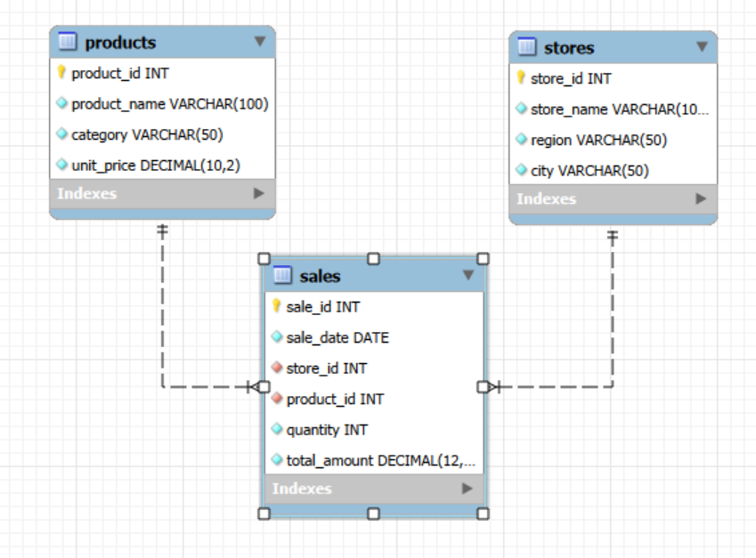

INSERT INTO good_retaildb.stores
SELECT * FROM bad_retaildb.stores_file;

SELECT * FROM stores;
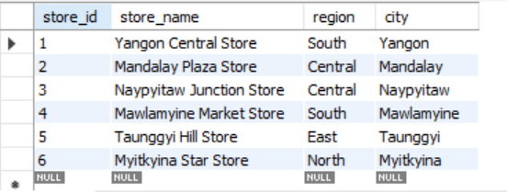

INSERT INTO good_retaildb.products
SELECT * FROM bad_retaildb.products_file;

SELECT * FROM products;
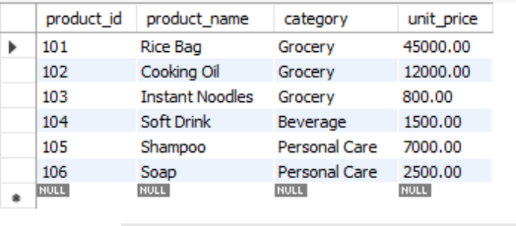

INSERT INTO good_retaildb.sales (sale_date, store_id, product_id, quantity,
total_amount)
SELECT sale_date, store_id, product_id, quantity, total_amount
FROM bad_retaildb.sales_file;

SELECT * FROM sales;
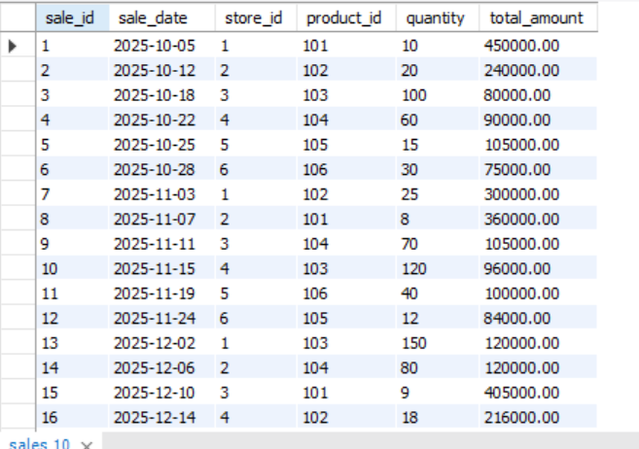

-- Sales report for last 6 months by region
SELECT
st.region,
SUM(s.total_amount) AS total_sales
FROM sales s
JOIN stores st ON s.store_id = st.store_id
WHERE s.sale_date BETWEEN '2025-10-01' AND '2026-03-31'
GROUP BY st.region
ORDER BY total_sales DESC;

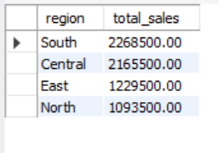

-- Sales report for last 6 months by region

SELECT
st.region,
SUM(s.total_amount) AS total_sales
FROM sales s
JOIN stores st ON s.store_id = st.store_id
WHERE s.sale_date BETWEEN '2025-10-01' AND '2026-03-31'
GROUP BY st.region
ORDER BY total_sales DESC;
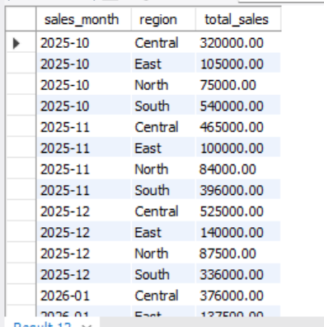

-- Ad-hoc report: sales by region and product category

SELECT
st.region,
p.category,
SUM(s.total_amount) AS total_sales
FROM sales s
JOIN stores st ON s.store_id = st.store_id
JOIN products p ON s.product_id = p.product_id
WHERE s.sale_date BETWEEN '2025-10-01' AND '2026-03-31'
GROUP BY st.region, p.category
ORDER BY st.region, total_sales DESC;

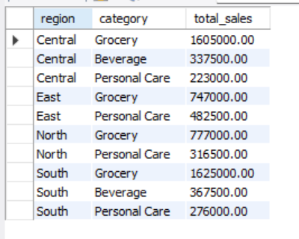

-- Create Reporting View

CREATE VIEW vw_sales_reporting AS
SELECT
s.sale_id,
s.sale_date,
st.store_id,
st.store_name,
st.region,
st.city,
p.product_id,
p.product_name,
p.category,
s.quantity,
s.total_amount
FROM sales s
JOIN stores st ON s.store_id = st.store_id
JOIN products p ON s.product_id = p.product_id;

SELECT * FROM vw_sales_reporting;
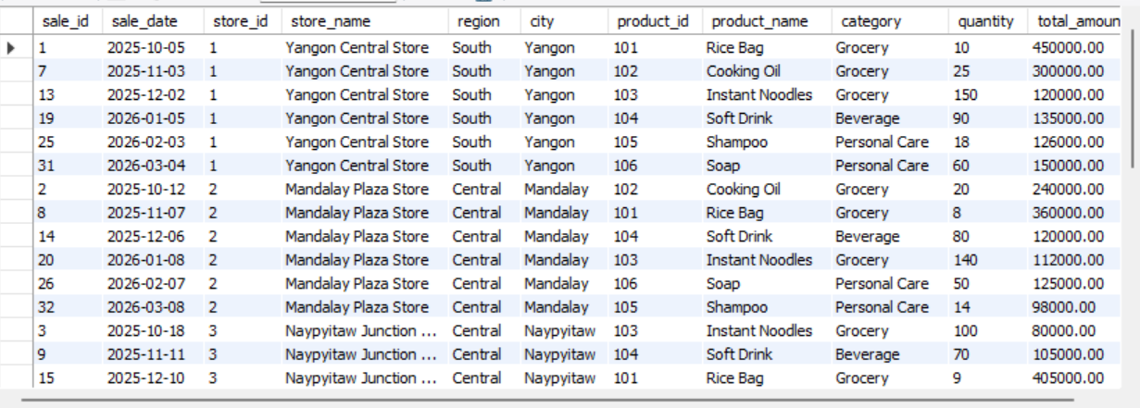

-- Test Case Scripts
-- Test Case 1: File-based access is difficult
-- Raw sales file does not directly show region

USE bad_retaildb;
SELECT
sale_id,
sale_date,
store_id,
total_amount
FROM sales_file
WHERE sale_date BETWEEN '2025-10-01' AND '2026-03-31';
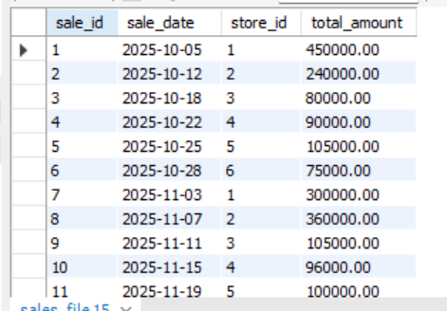

-- Test Case 2: Join is required to retrieve region
SELECT
s.sale_id,
s.sale_date,
st.region,
s.total_amount
FROM sales_file s
JOIN stores_file st ON s.store_id = st.store_id
WHERE s.sale_date BETWEEN '2025-10-01' AND '2026-03-31';
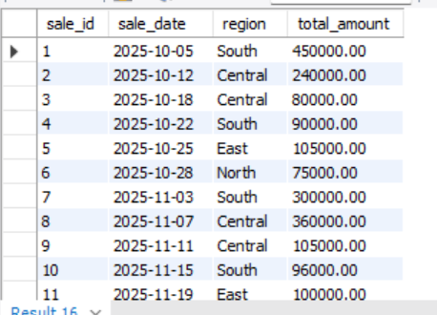

-- Test Case 3: DBMS quickly answers manager’s question
USE good_retaildb;

SELECT
st.region,
SUM(s.total_amount) AS total_sales
FROM sales s
JOIN stores st ON s.store_id = st.store_id
WHERE s.sale_date BETWEEN '2025-10-01' AND '2026-03-31'
GROUP BY st.region
ORDER BY total_sales DESC;
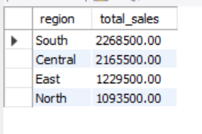

-- Test Case 4: Ad-hoc reporting
SELECT
region,
COUNT(*) AS transaction_count,
SUM(total_amount) AS total_sales
FROM vw_sales_reporting
WHERE sale_date BETWEEN '2025-10-01' AND '2026-03-31'
GROUP BY region
ORDER BY total_sales DESC;

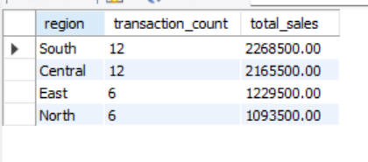

-- Test Case 5: Monthly trend by region
SELECT
DATE_FORMAT(sale_date, '%Y-%m') AS sales_month,
region,
SUM(total_amount) AS total_sales
FROM vw_sales_reporting
WHERE sale_date BETWEEN '2025-10-01' AND '2026-03-31'
GROUP BY DATE_FORMAT(sale_date, '%Y-%m'), region
ORDER BY sales_month, region;
